**Live Chat**

**Introduction**

The live chat feature in the website focuses on enabling the communication between members within the same trading platform. This way members would be able express their views to others or have discussions about the topics they are not sure of. Providing a live chat within the same trading platform is quick and easy for members rather them going to Facebook or Twitter to speak about trading. Furthermore, members using other communications applications/websites could cause misunderstanding if they have any questions about the Vortex.

Scenario: Members should be able to communicate with other users within the platform

User Story 1:

**Story:** As a member, I want to be able to send messages to other members using Vortex so that I am able to discuss my views and have conversations about any uncertainties.

**Detail:** All members will have access to the live chat page, they will be able to navigate to the live chat page which will display a chat box with a text box and a send button to send messages. Members will enter messages in the text box then send it through to the chat box.

**Test:** When in the live chat page, check if there is a chat box with a text box and a send button. Check if send button sends messages to chat box.

UML Use Case Scenario:

|  |  |
| --- | --- |
| Use case name | Send Message |
| Participating actors | API |
| Flow of events:  Normal flow | 1. Member is directed to main page after login 2. Member navigates to live chat page 3. Member enters a message and then sends it |
| Flow of events:  Alternative flow | Empty string:   1. Member is directed to main page after login 2. Member navigates to live chat page 3. Member leaves input box empty and then sends it 4. Message does not send due to the input box being empty |
| Pre-condition | Member hasn’t sent a message |
| Post-condition | Member sent a message  Member hasn’t sent a message |

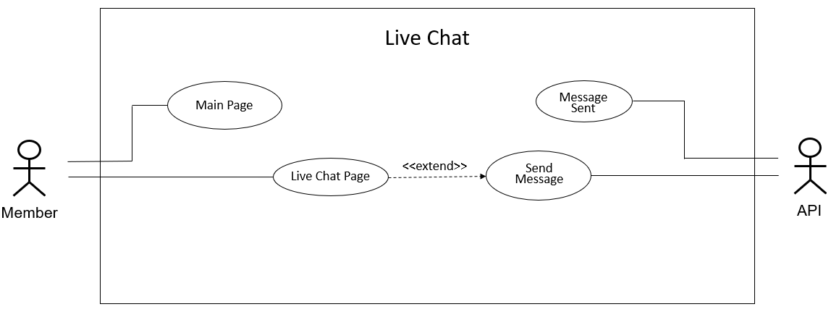UML Use Case Diagram:

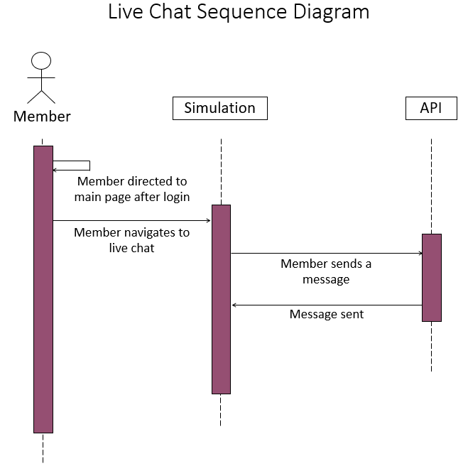UML Sequence Diagram:

User Story 2:

**Story:** As a member, I want to be able to receive messages from other members using Vortex so that I am able to receive answers to any messages I send and solve any uncertainties.

**Detail:** All member will have access to the live chat page, they will be able to navigate to the live chat page which will display a chat box with a text box and a send button to send messages. Members will enter messages in the text box then send it through to the chat box. Other members will then send replies to those messages which will be received by all members in the live chat page and display in chat box.

**Test:** When in the live chat page, check if there is a chat box with a text box and a send button. Check if send button sends messages to chat box and members are receiving them.

UML Use Case Scenario:

|  |  |
| --- | --- |
| Use case name | Receive Message |
| Participating actors | Member |
| Flow of events:  Normal flow | 1. Member is directed to main page after login 2. Member navigates to live chat page 3. Member enters a message and then sends it 4. Members then receive the message and it is displayed in chat box |
| Flow of events:  Alternative flow | Empty string:   1. Member is directed to main page after login 2. Member navigates to live chat page 3. Member leaves input box empty and then sends it 4. Message does not send due to the input box being empty 5. Members don’t receive a message |
| Pre-condition | Members don’t receive message |
| Post-condition | Members receive message  Members don’t receive a message |

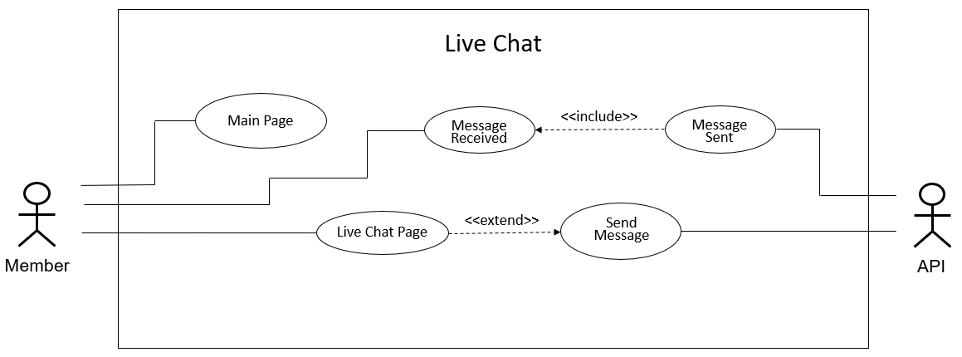UML Use Case Diagram:

UML Sequence Diagram:

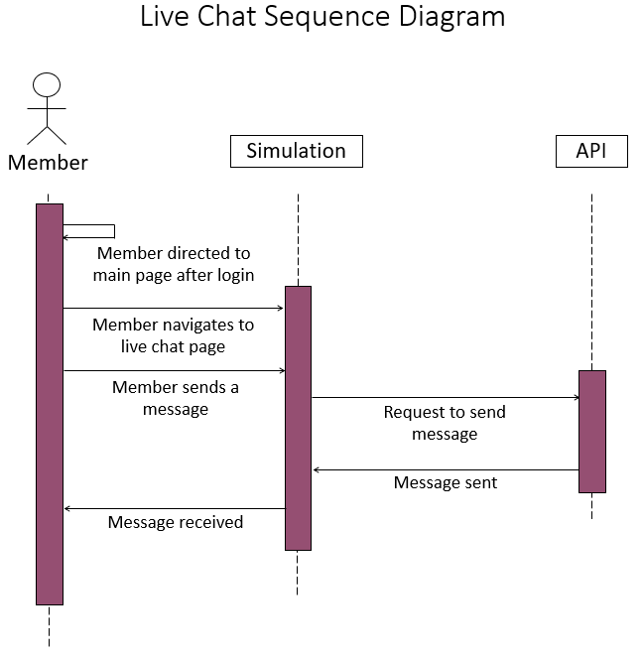

User Story 3:

**Story:** As a member, I want to be able to view messages from other members using Vortex so that I am able to get an understanding of the views of other members.

**Detail:** All member will have access to the live chat page, they will be able to navigate to the live chat page which will display a chat box with a text box and a send button to send messages. Members will not need to send a message; they will be able to stay on the page and just view messages sent to the chat box by other members.

**Test:** When in the live chat page, check if there is a chat box with a text box and a send button. Check if messages are viewed in the chat box which is sent by other members.

UML Use Case Scenario:

|  |  |
| --- | --- |
| Use case name | View Message |
| Participating actors | Member |
| Flow of events:  Normal flow | 1. Member is directed to main page after login 2. Member navigates to live chat page 3. Member can view messages in chat box |
| Flow of events:  Alternative flow | No messages:   1. Member is directed to main page after login 2. Member navigates to live chat page 3. Member cannot view any message because there are no messages in the chat box |
| Pre-condition | Member can view message |
| Post-condition | Member can view message  Member cannot view message |

UML Use Case Diagram:

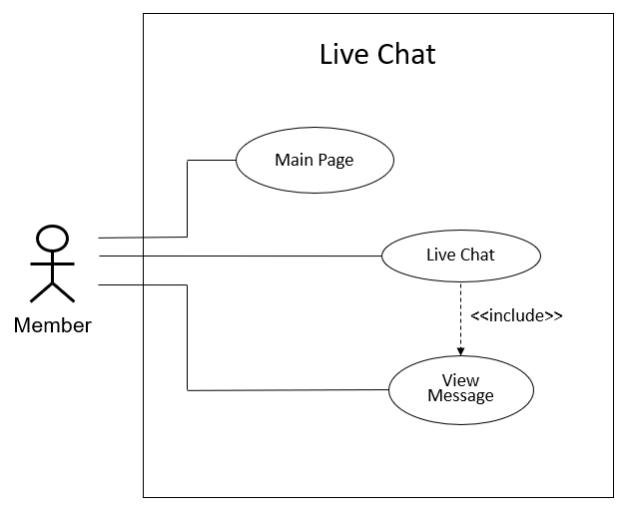

UML Sequence Diagram:

